Name: Jack

Student ID: D1166506

In order to fulfill the required function, I separated and coded the program into 3 parts. Since there isn’t any extra acquired operation to do with, I only used the stdio library.



Frist part of this program is to print all 32 bits of the variables in binary. To do this, I use the loop and right shift operator (>>) to get each bit of the integer variables n and print a space every 4 bits.

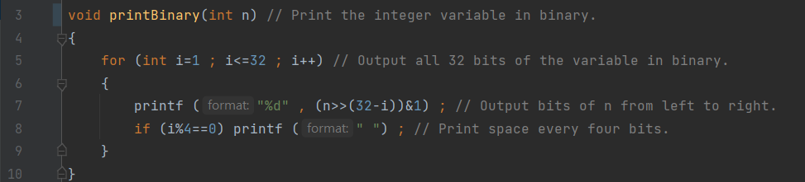

Next, the most important part, is to make a full adder. Because calling half adder in a full adder will increase the work of the program, I made a full adder only instead. In the function adder, it has to input X and Y variables in integer type and the addresses of carry, ans, and overflow.

